Computer Networks

Lab 05

Hamza Shahid
20P-0117
BSSE-5A

Task 01:

Steps:
- First make this protocol by drag and drop.
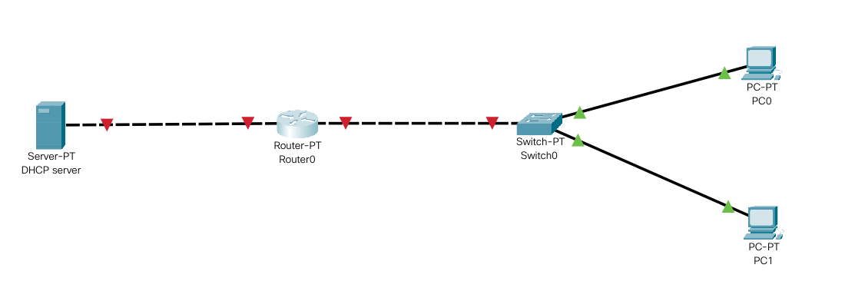
- Then setup the DHCP server.

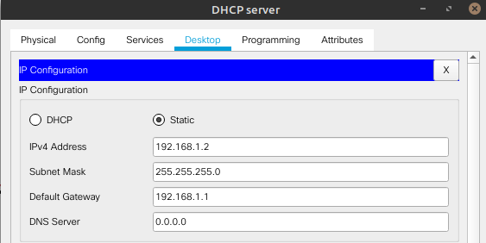
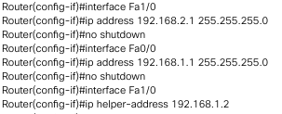

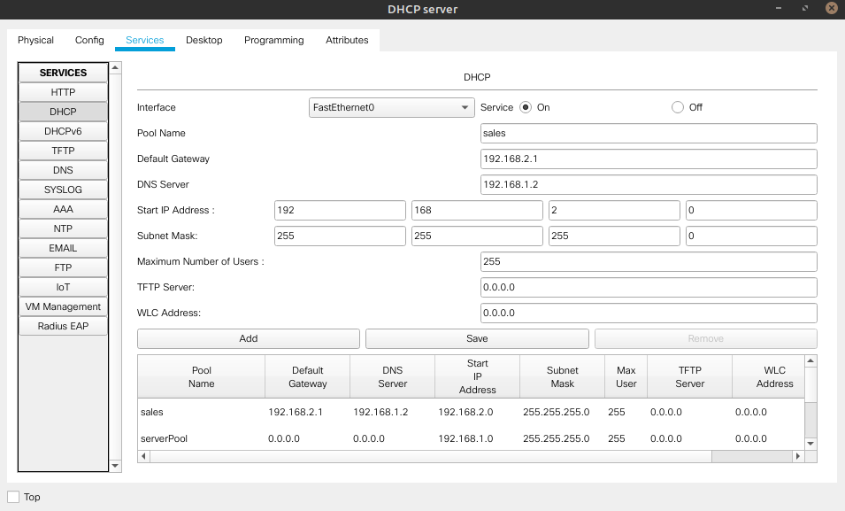

- Then turn all the PCs to the DHCP. And the IP will be assigned automatically.

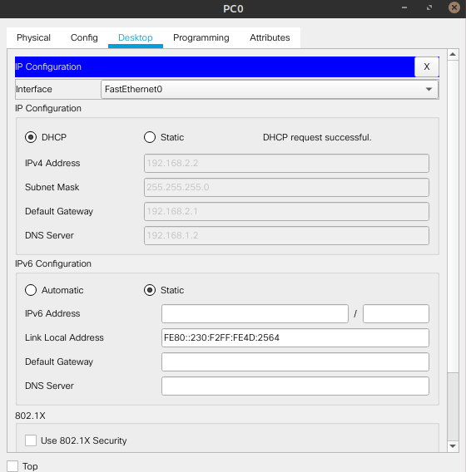
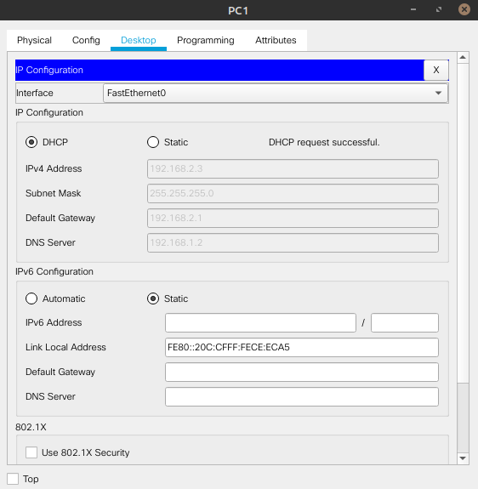
Task 02:

Steps:
- First make this protocol by drag and drop as we did in Lab#04.
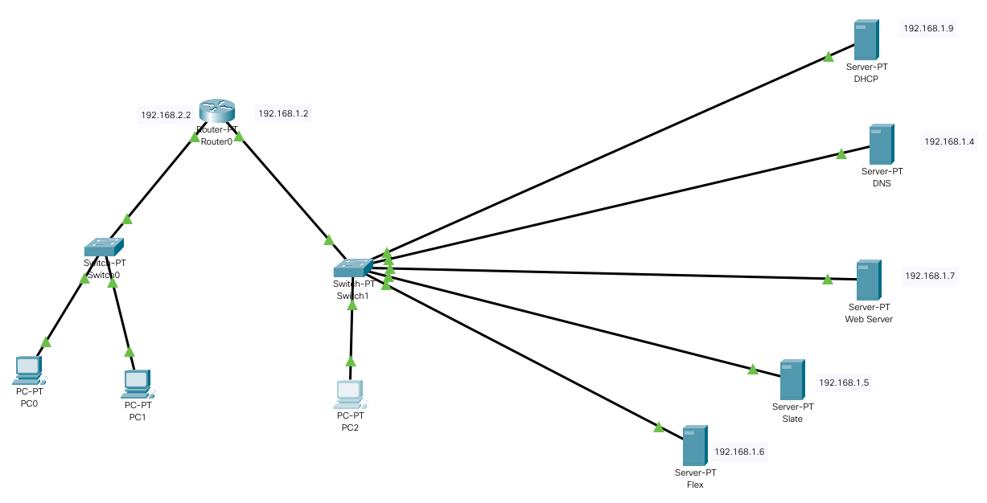

- Then add Flex and Slate as servers in protocol and assign IP addresses to them.
- Now if you go to to PC and access the slate or flex by their IP, you can see the changes you did in their index files.

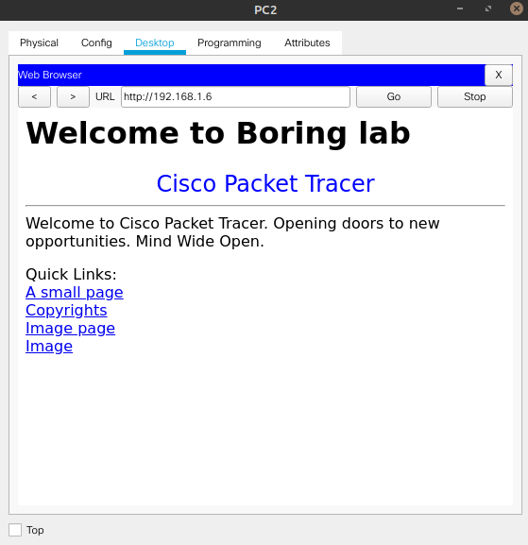

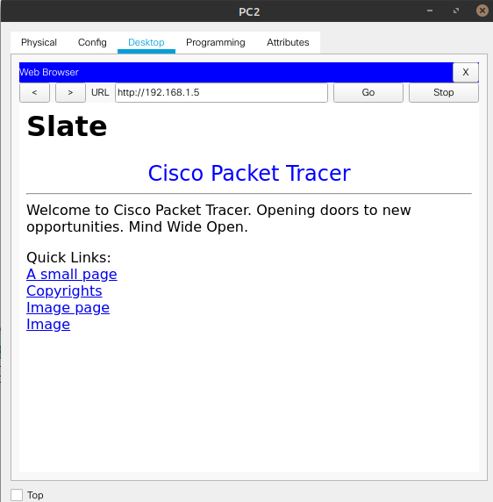

(a):
When we access it with the IP, it directly access the IP without sending request to DNS server.

(b):
When we access it with the URL, it sends request to DNS server and then access the desired server.

